Cross-Checks’ Report

Compiled on 07/06/2023, 09:16

Table of Contents

*Loading FDI catch data (Table A)*

*Loading MED & BS Landing table*

# Cross-checks

## Comparing total landings in weight between MEDBS and FDI EU Data Calls

Both MED & BS Landing table and FDI Table A Catch were analysed to report the mutual consistency of the total landings in weight.

*GSA18*

*HKE*

Plot of total landings in weight HKE - ITA - GSA18

*Summary table of total landings in weights.*

YEAR

COUNTRY

GSA

SPECIES

LANDINGS

DATA_CALL

2018

ITA

GSA18

HKE

2000.253

MEDBS

2018

ITA

GSA18

HKE

2000.257

FDI

*MUT*

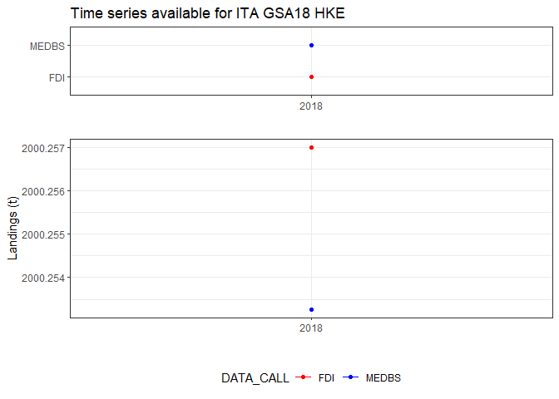 Plot of total landings in weight MUT - ITA - GSA18

*Summary table of total landings in weights.*

YEAR

COUNTRY

GSA

SPECIES

LANDINGS

DATA_CALL

2018

ITA

GSA18

MUT

1003.854

MEDBS

2018

ITA

GSA18

MUT

1003.851

FDI

*GSA19*

*HKE*

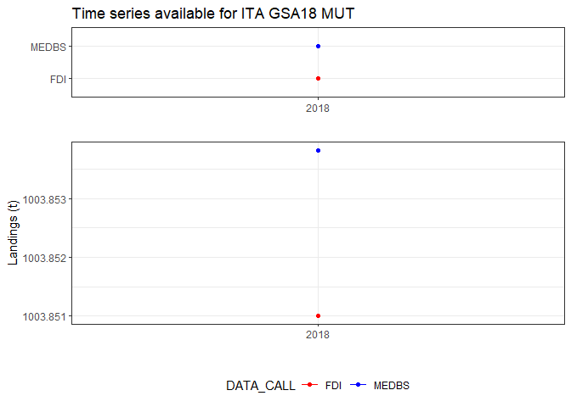 Plot of total landings in weight HKE - ITA - GSA19

*Summary table of total landings in weights.*

YEAR

COUNTRY

GSA

SPECIES

LANDINGS

DATA_CALL

2018

ITA

GSA19

HKE

659.6122

MEDBS

2018

ITA

GSA19

HKE

659.6110

FDI

*MUT*

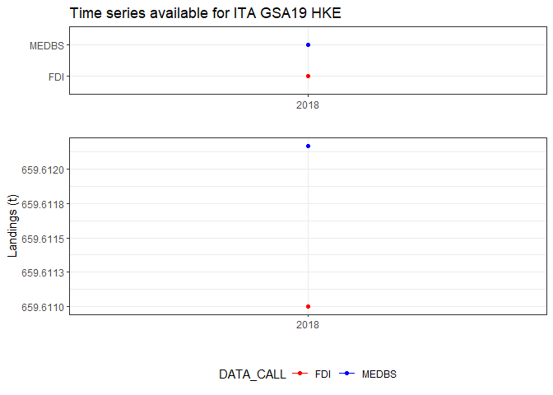 Plot of total landings in weight MUT - ITA - GSA19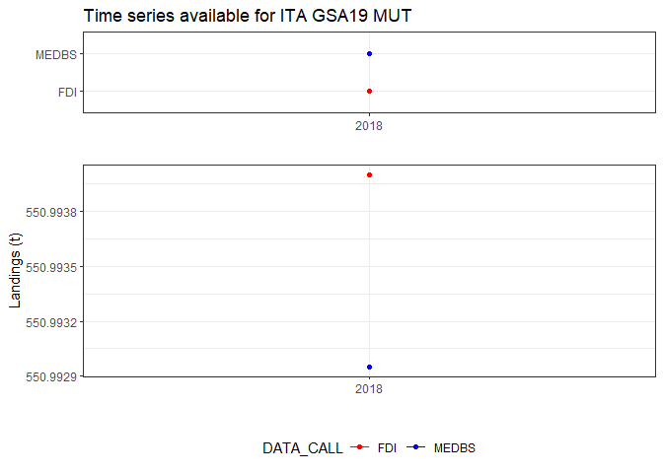

*Summary table of total landings in weights.*

YEAR

COUNTRY

GSA

SPECIES

LANDINGS

DATA_CALL

2018

ITA

GSA19

MUT

550.9929

MEDBS

2018

ITA

GSA19

MUT

550.9940

FDI